

Jordan university of Science and Technology

**Computer Engineering Department CPE480**

**HW3**

**Name: Notes:**

**1- Due date is 11/1/2024 at 10:00 PM.**

**2- Use this document to submit this project, fill all required items inside this file:**

**Work:**

Write a Matlab code to implement a neural network that will predict if the house price is above median price or not based on the values of the 10 features given for each house. Required items are:

1. Code.
2. A figure of the architecture of the neural network.

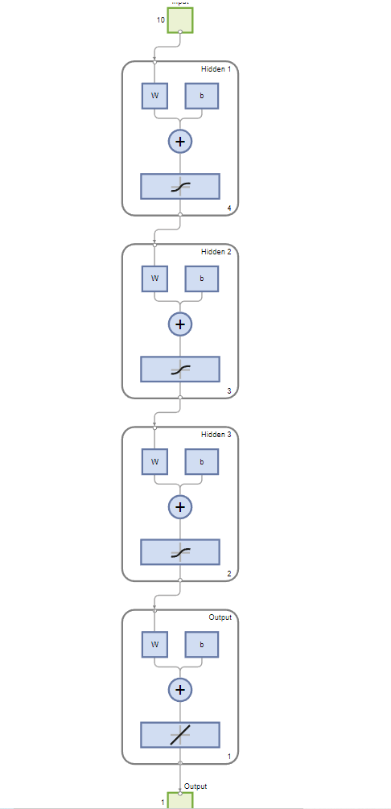

1. A table of the weights and bias of all perceptrons.

Bias:

|  |  |  |  |  |
| --- | --- | --- | --- | --- |
|  | B1 | B2 | B3 | B4 |
| L1 | -3.190001557401585 | -2.92014765304375 | 2.04934112887699 | -5.82910728866312 |
| L2 | -2.827979624166896 | 0.798281909201369 | -4.229820069575601 |  |
| L3 | 5.230934182113875 | -0.82312242349835 |  |  |
| L4 | -0.028001786420867 |  |  |  |

Input layer weights:



3X4

|  |  |  |  |  |  |  |  |  |  |
| --- | --- | --- | --- | --- | --- | --- | --- | --- | --- |
| -0.0768 | -0.7437 | 0.3873 | 2.5084 | -1.5261 | 1.1099 | -2.4480 | -4.9523 | 2.4136 | 0.5612 |
| 0.1841 | 0.2778 | -1.4309 | -3.2839 | -4.4577 | -1.4015 | 3.1237 | 4.9261 | -3.6253 | -2.1797 |
| 4.8529 | 2.1094 | 0.5266 | -1.7746 | 0.0231 | 0.5178 | -1.0212 | 1.1577 | -1.6437 | -0.4717 |
| -4.1710 | 0.1647 | 0.9560 | -2.2772 | -0.1833 | -0.0972 | -0.7932 | -0.1217 | -0.6981 | -0.3692 |
| 3-Layers weights |  |  |  |  |  |  |  |  |  |
| 1.7965 | -3.8196 | 1.1956 | -0.0068 | -1.8980 | -7.1765 | 13.78 | -5.783 | 1.997 | 1.05 |
| 3.2287 | 10.21 | -5.2 | -14.322 | 9.488 | -1.19 | -1.55 | 3.199 | -0.915 | -0.0633 |





1. A testing that include trying the test samples and calculating the accuracy of the system.

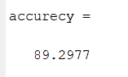



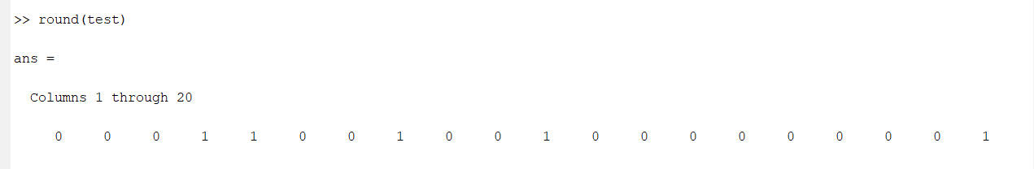



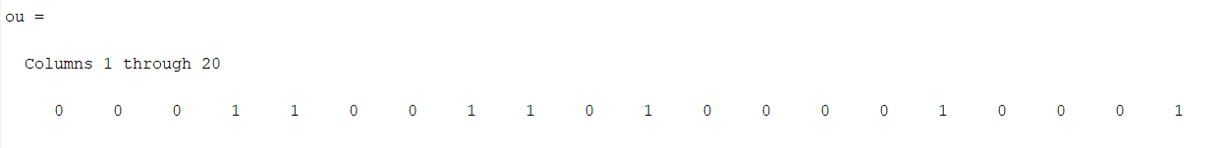



The training and testing data is provided in the (housedata) file provided with this project. Use the first 700 samples for training and the remaining samples for testing.